1. **Use HLOOKUP to find the sales for Product A in March.**

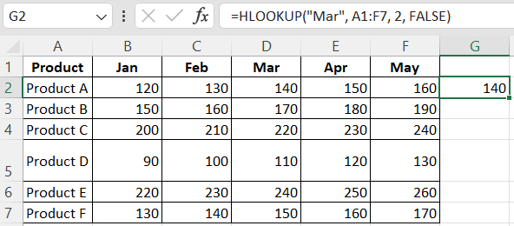

1. **Use HLOOKUP to find the sales for Product D in May.**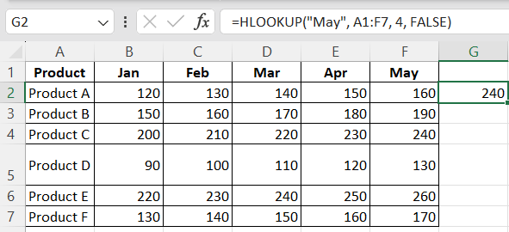
2. **Use HLOOKUP to find the sales for Product C in February.**

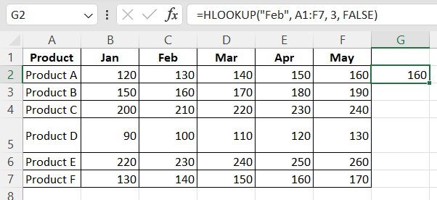

**4. Use HLOOKUP to find the sales for each month for a product, then calculate the**

**total sales for that product.**

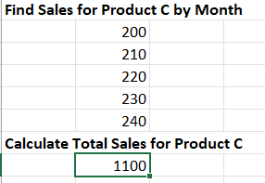

**5. Use HLOOKUP to find the maximum sales value for Product B across all months.**

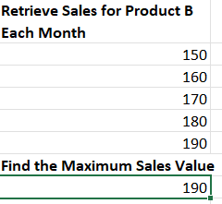

**6. Use HLOOKUP to find the minimum sales value for Product F across all months.**

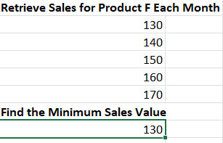

**7. Use HLOOKUP to find the average sales value for Product E across all months.**

